Dear Recipient:
I am so excited about this recent opportunity that I have been given to be part of a Royal Family Kids Camp this summer. It will be the first week of July, and we will work directly with foster care kids. These children, ages 6 to 12, have experienced trauma in the form of abuse, neglect, and abandonment. Royal Family Kids Camp gives these kids a week of fun and treats them like royalty because that's who they are.
I need to raise money to volunteer at this camp. Could you help me reach the invisible mission field of local foster children? This truly is a mission trip for me. It's a chance for me to show the love of Jesus to these precious children.
Would you please consider praying for me that God would use me during this week and praying about supporting me financially?
If you write a check, you can make it out to OneFamily and put my name in the memo. Or you can click the link below to give online. Please note that any overage that I raise will go to helping a child attend camp.
Thank you again for helping me reach the mission field in my region- the abused and neglected children where I live.

Sincerely,
Your Name
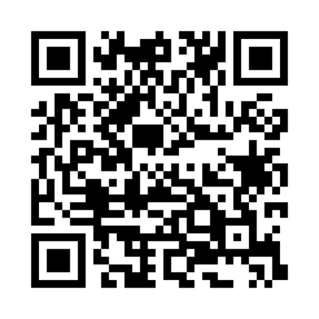
To make an online donation on my behalf for this mission trip, please scan the QR code, or visit: https://bit.ly/3NjhLfn

